**Draw a story map to retell the Christian story of Easter.**

[https://www.youtube.com/watch?v=Wnbo2AmS3OI](https://www.youtube.com/watch?v=Wnbo2AmS3OI)

**Easter toilet roll crafts**

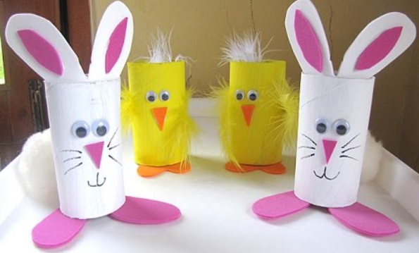

Easter Jokes and Printable activities -<https://www.activityvillage.co.uk/easter-jokes>

BBC Easter Recipes for kids- <https://www.bbcgoodfood.com/recipes/collection/easter-kids>

Watch the Easter Story - <https://www.youtube.com/watch?v=Y3UKd6LQKng>

**We want to hear from you!**

Please keep in contact with us over Easter. We LOVE getting Dojo messages from you. Send photos of your ‘eggcellent’ adventures and of you having fun.

**Year 2**

**Easter Activities**

Make a Happy Easter card and put it in your window to make people walking by smile.

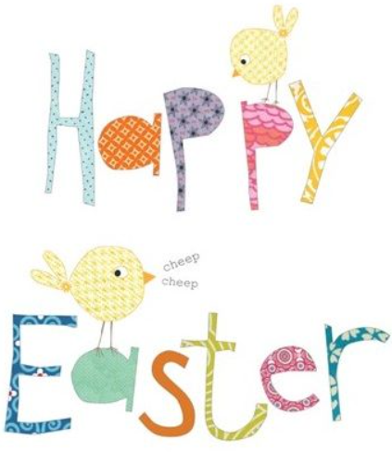

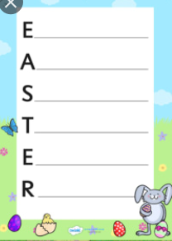

**Create an Easter acrostic poem.**

**Outdoor Fun**

Challenge your adults or siblings to an egg and spoon race in the garden. You could also have a 3 legged race or a wheel barrow race.

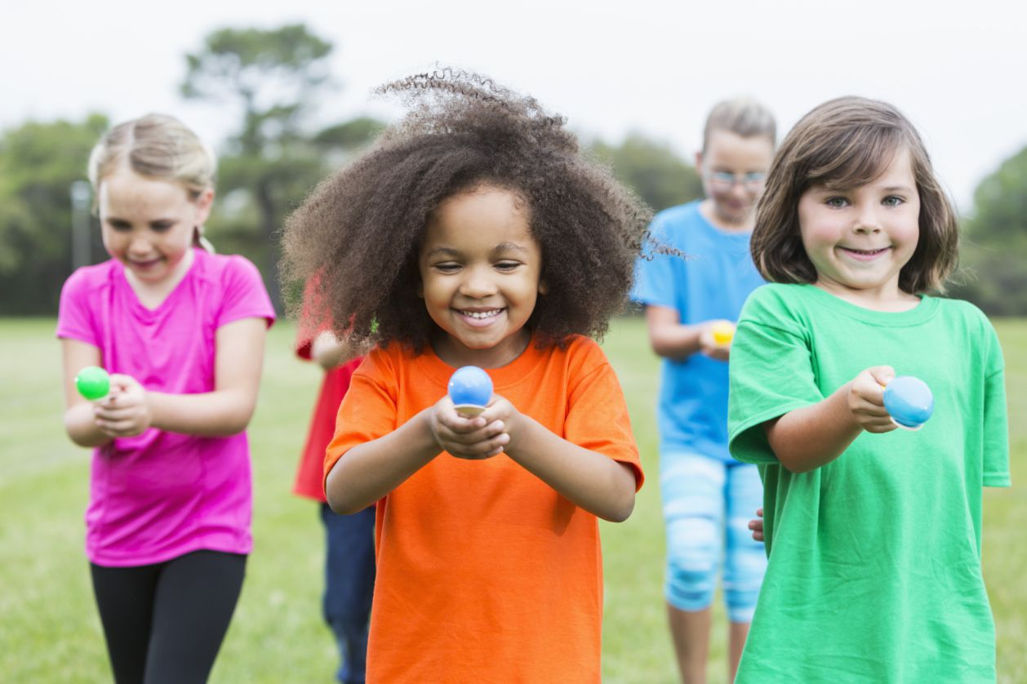

**Traditional Egg Decorating**

Maybe you have some eggs that are out of date? Why not decorate them like you did for competitions when you were younger.

